Complex numbers

What are they?
Today we are going to look at "the most remarkable formula in mathematics". A formula which in real numbers does not make any sense at all.
What does it mean and how does it influence our lives? Complex numbers are the combination of real and imaginary numbers. Complex numbers arise from the need to express negative numbers’ roots, which real numbers can’t do. This is why they reflect all the roots of polynomials.
If we base this equation on real numbers it comes up as a mistake.

But if we operate on complex numbers the solution of this equation is:

Definition of a complex number
A number has a complex character when:

where: a,b∈R
a is a real part of a complex number and b is an imaginary part of a complex number

Conjugate numbers
Let's assume we have a given complex number .
Then, the number is called the conjugate of and is denoted by the symbol .
So:

In the Cartesian coordinate system, a conjugate number is the X-axis symmetrical reflection of a complex number
For example:
If than

Basic operations on complex numbers

Addition
Addition in complex number is very basic. It’s just like adding two algebraic expressions in primery school
For example:

Subtraction
Subtraction of complex numbers is similar to addition but involves subtracting corresponding parts of two complex numbers.
For example:

Multiplication
Let's multiply the complex numbers using the "term by term" method:

Division
Let’s say that I want to divide a complex number by another complex number. What we have to do.

Where
So, to divide a+bi by c+di, you would multiply both the numerator and the denominator by the conjugate of the denominator, which is c−di.
The expression would then become:

Example:

Modulus of a complex number
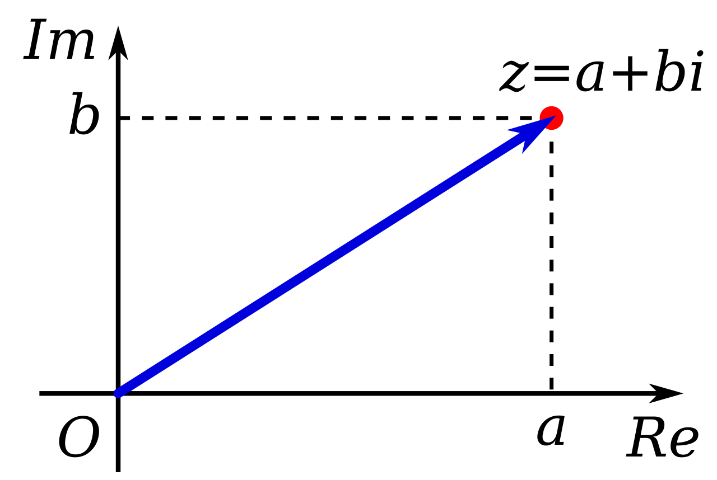
As you know, complex number can be described in cartesian coordinate system. Because the figure under the graph is a right triangle, we can calculate the modulus of the complex number using the Pythagorean theorem.

The geometric interpretation of a complex number
As you can see, there is an angle between modulus of a complex number and x-axis.
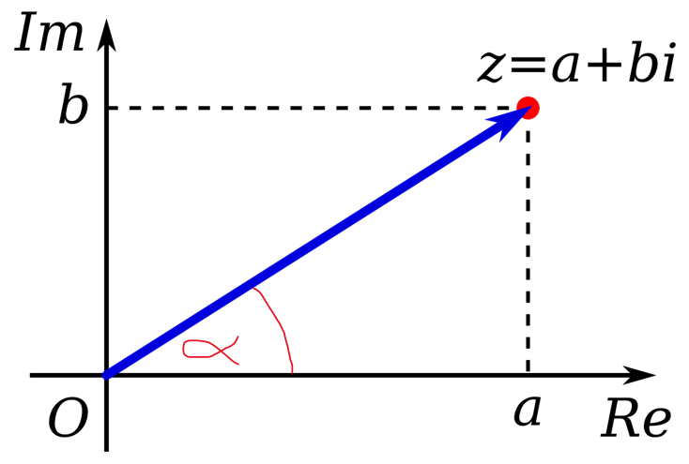
We call the number α the argument of the complex number z, denoted as arg z.
So if we want to contain angle in a complex number we have to use trigonometric functions

Where:

So that’s why:

Exponentiation of complex numbers
Before we were calculating some basic operations on complex numbers. Let’s advance it.
As you can remember
So than we can use The de Moivre's theorem:

Root of complex numbers
As you can remember from our maths lessons so that’s why:

Why do we need complex numbers?
Imaginary and complex numbers play crucial roles across multiple fields like physics, engineering, and geometry. They're indispensable for measuring sine or cosine waves, essential in electricity for both household needs and cell phone signals. These numbers are vital in understanding alternating current (AC) electronics, ensuring safety while working with electricity.
Moreover, complex numbers are fundamental in the design of technology, facilitating the language of transistors and microchips. They're integral to wireless technology and medical imaging, aiding in interpreting scans and ensuring internet connectivity. In quantum physics, they model periodic motions such as waves. Additionally, complex numbers help assess earthquake data for building safer structures and inform weather forecasting models, influencing various aspects of modern life, including accessing this blog.

